|  |  |
| --- | --- |
| **Name** | **Enayathulla A** |
| **Date** | **05/01/2024** |
| **Type** | **Daily Assignment** |
| **Topic** | **Azure Data Factory and Copy Activity in ADF** |

**Azure Data Factory:**

Azure Data Factory is a cloud-based data integration service provided by Microsoft Azure. Its primary purpose is to help organizations efficiently collect, process, and move data from various sources to different destinations.

**Copy Activity in Azure Data Factory:**

Step1🡺 I created one blob storage account (enayathullasource) this will act as source.

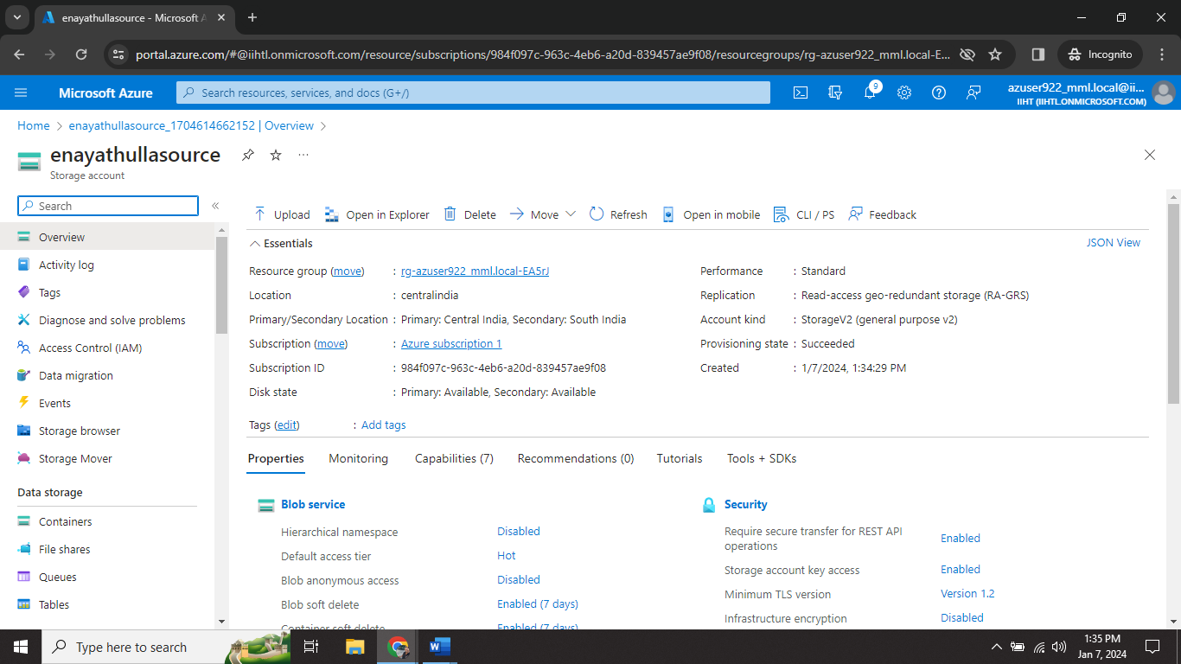

Step2🡺 create one container (source) and upload files into it(Salary_Data.csv).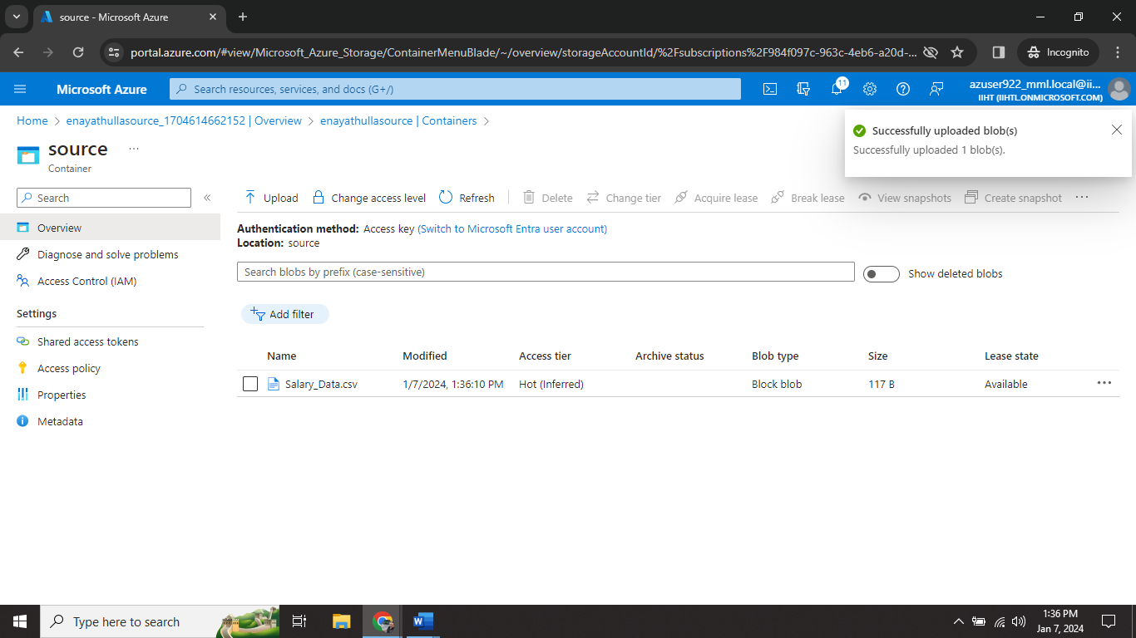

Step3🡺 I created another storage account (enayathulladestination) this is act like a destination account.

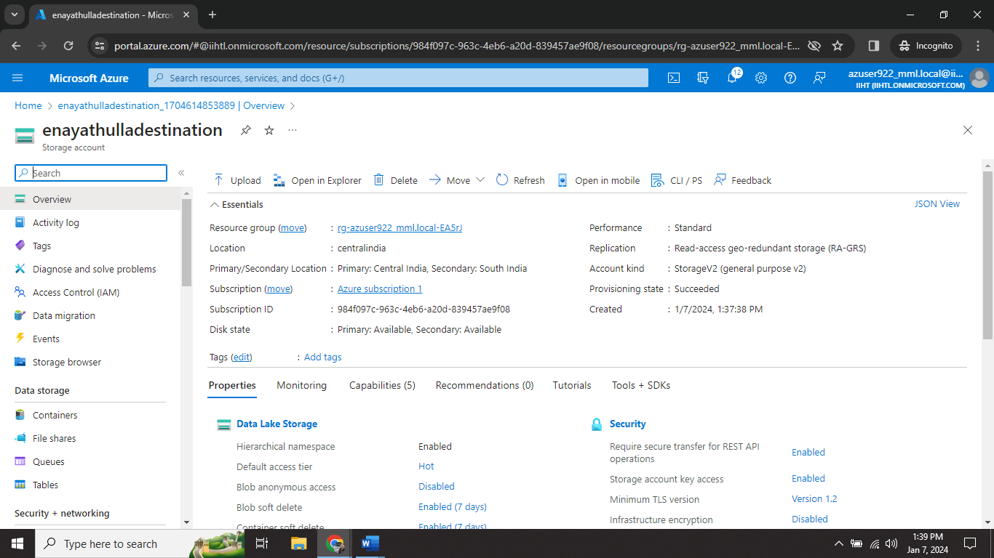

Step4🡺 created one container (destination) for receive files.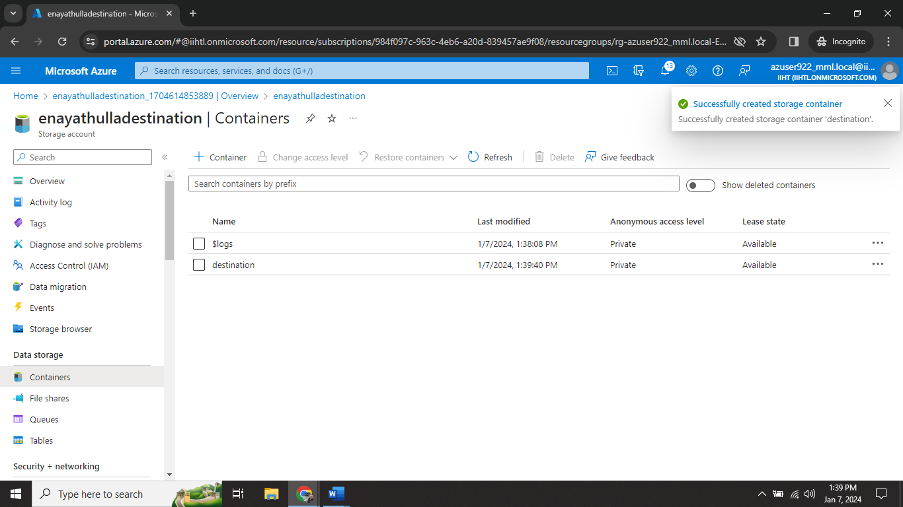

Step5🡺 I created one Data Factory (EnayathullaDataFactory).

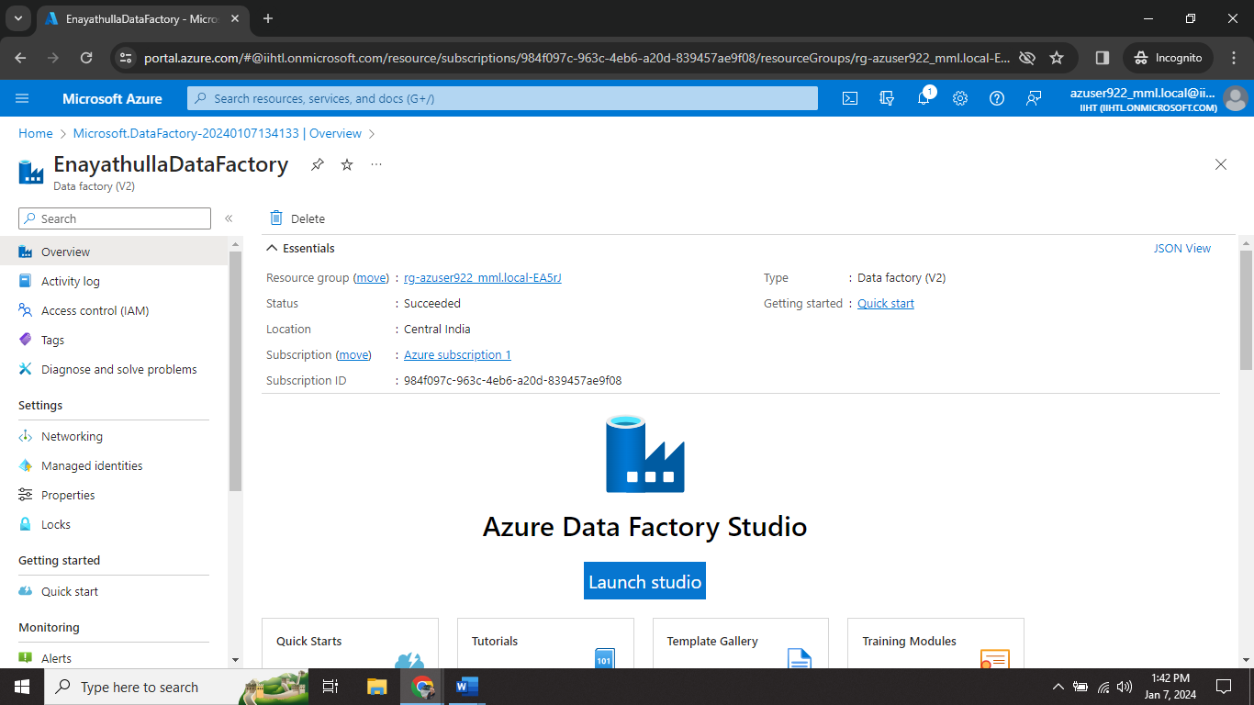

Step6🡺 Enter Launch studio.

Step7🡺 In this page of azure data factory and by selecting ingest to perform the process.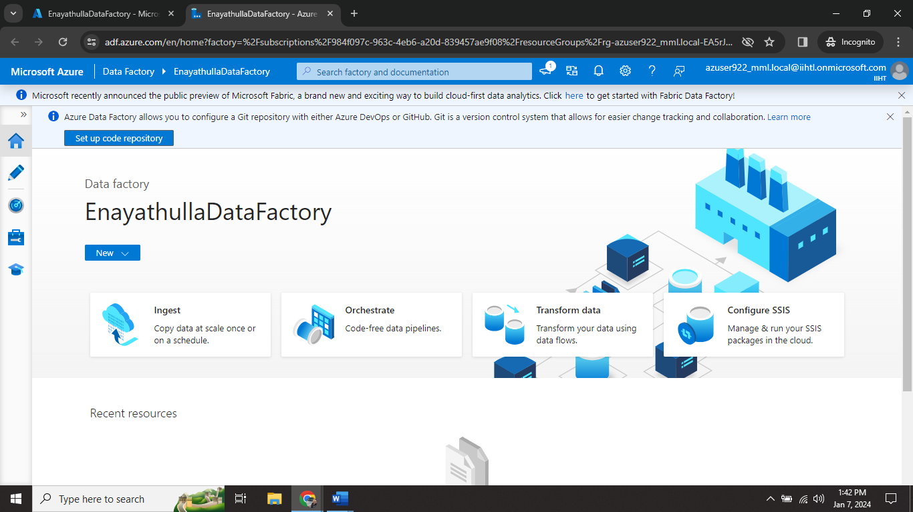

Step8🡺 Now select Built in copy task.

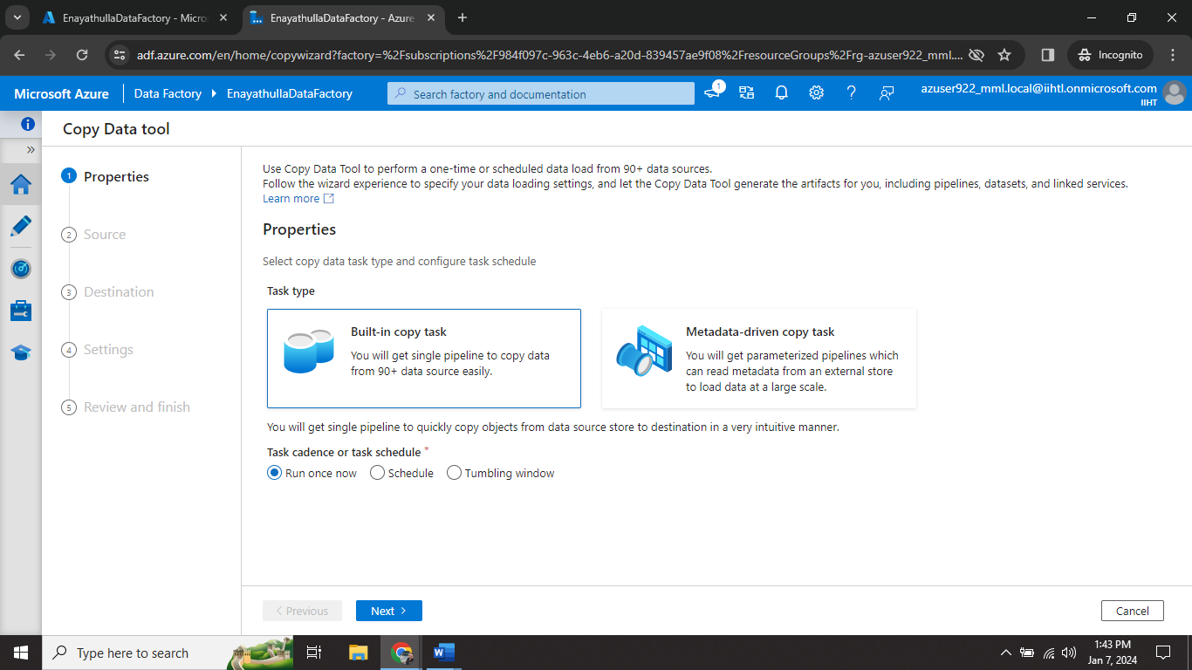

Step9🡺 Now select source data store and click new connection; fill all the details.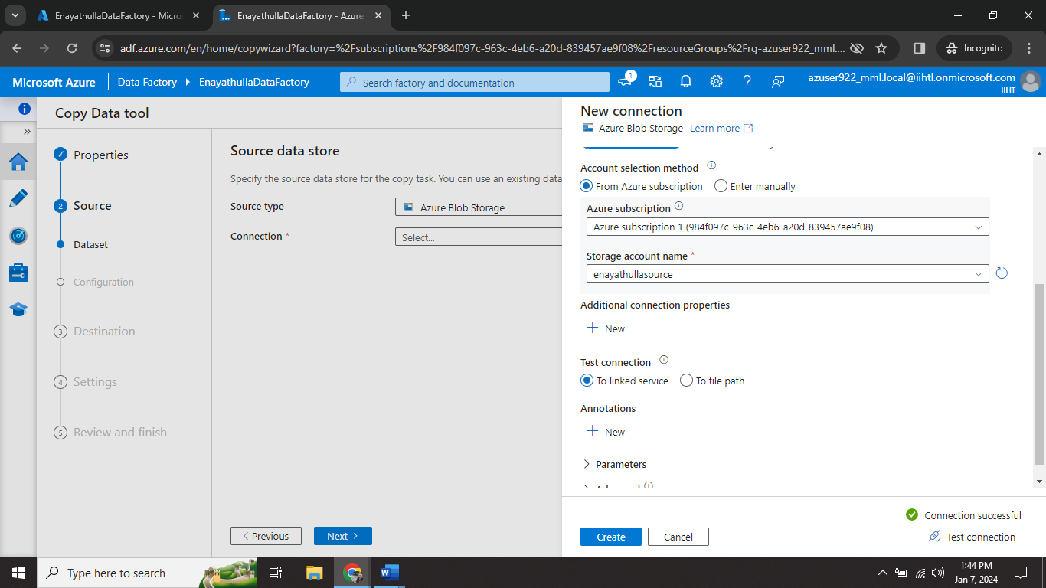

Step10🡺 now select source container (source).

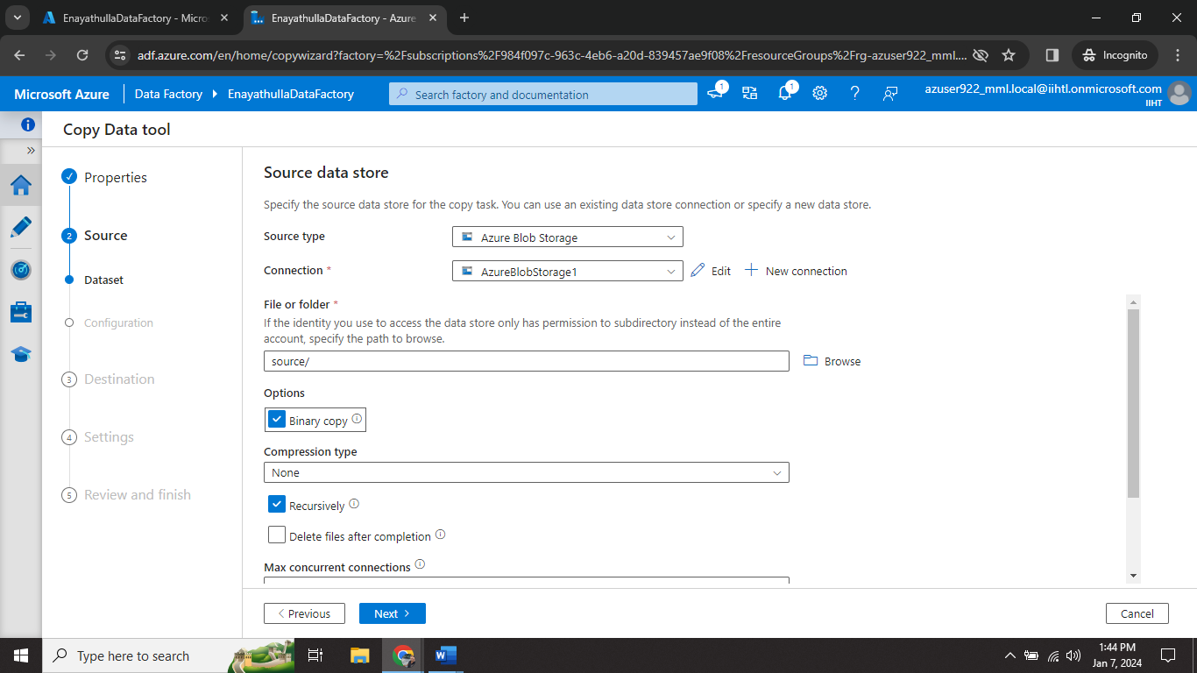

Step11🡺 In destination data store connect the connection and test connection.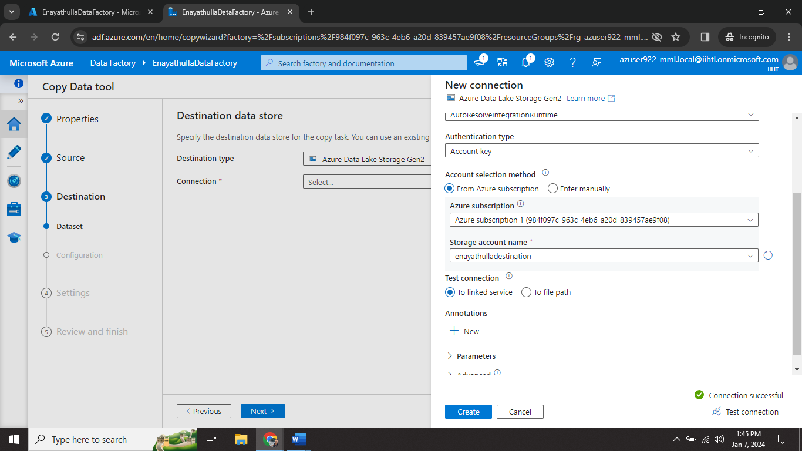

Step12🡺 now select the destination container in destination storage (destination).

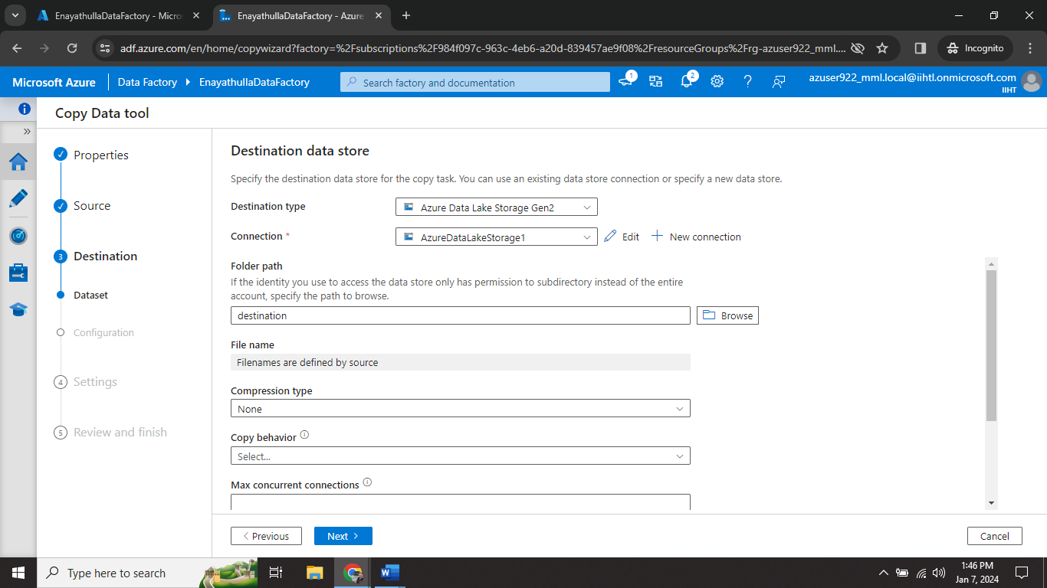

Step13🡺In settings tab give Task name (CopyPipeline_Enayathulla).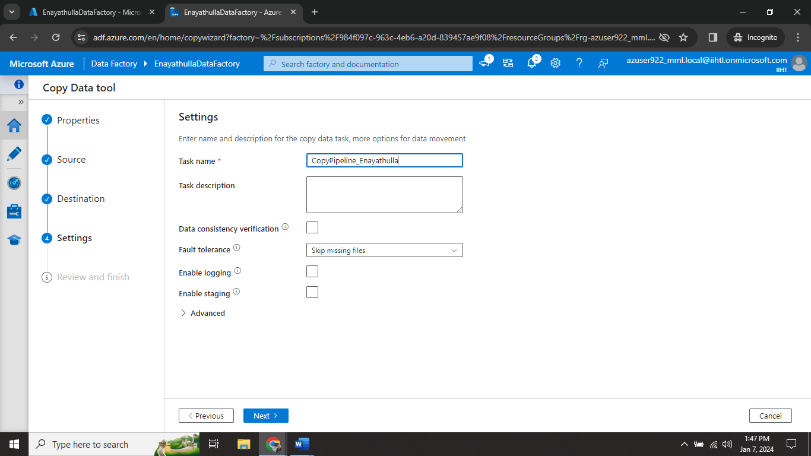

Step14🡺 In summary tab check all details and give next.

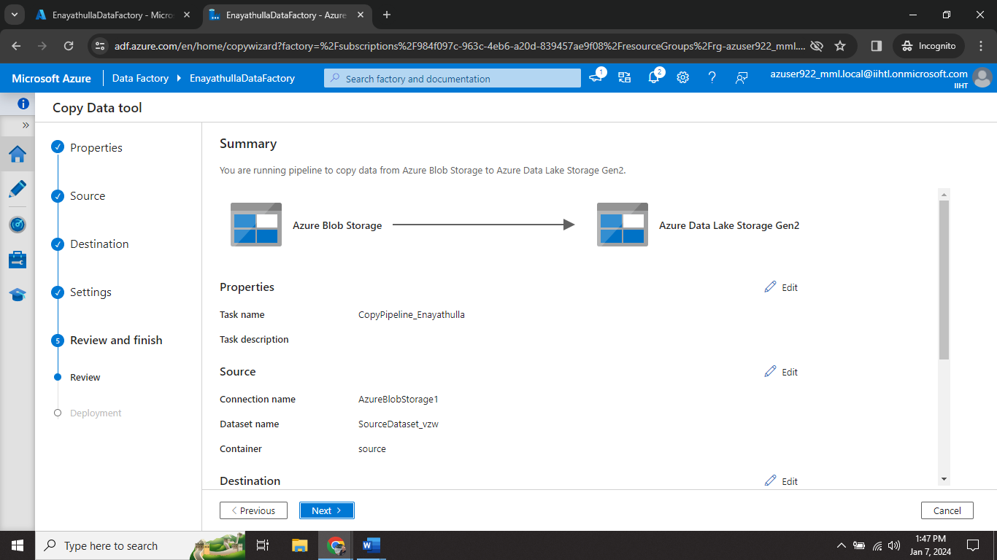

Step15🡺 After completing deployment process press Finish.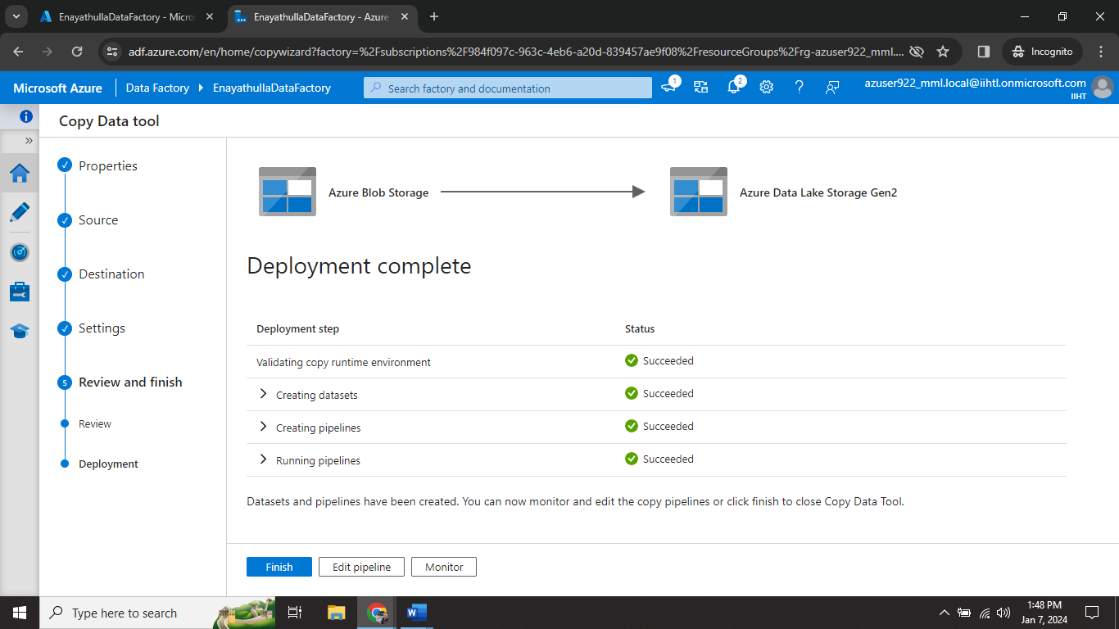

Step16🡺 Now we can see our files in destination container.

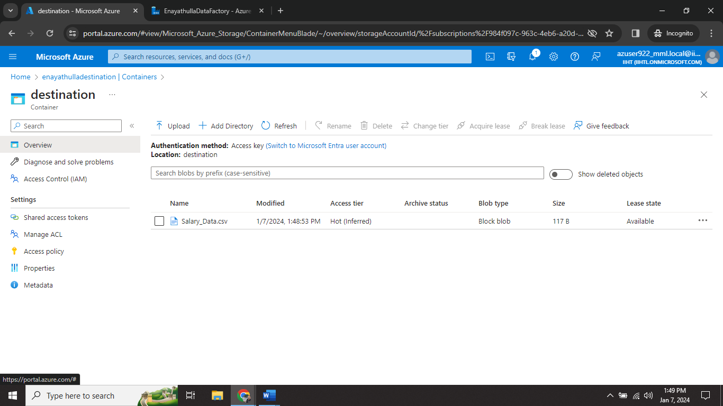

Step17🡺 we can able to perform the pipeline again by clicking validate and Debug.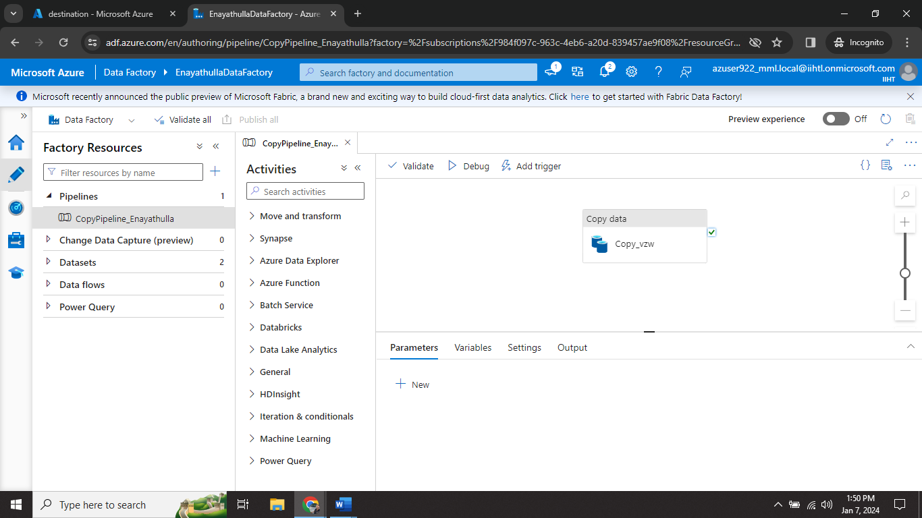

Step18🡺 Delete Data Factory(EnayathullaDataFactory).

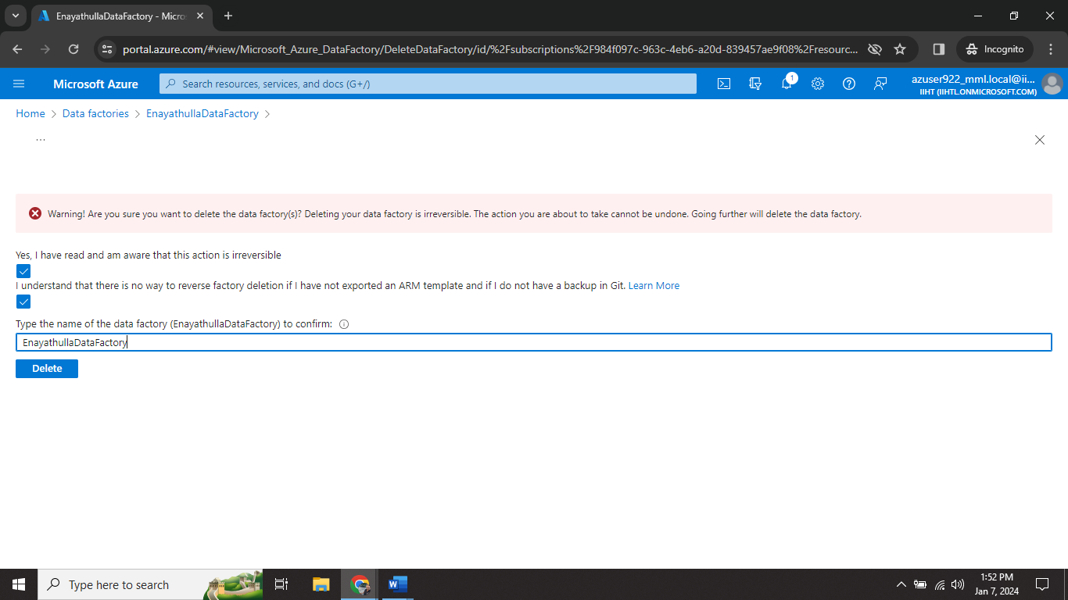

Step19🡺 delete source storage account(enayathullasource).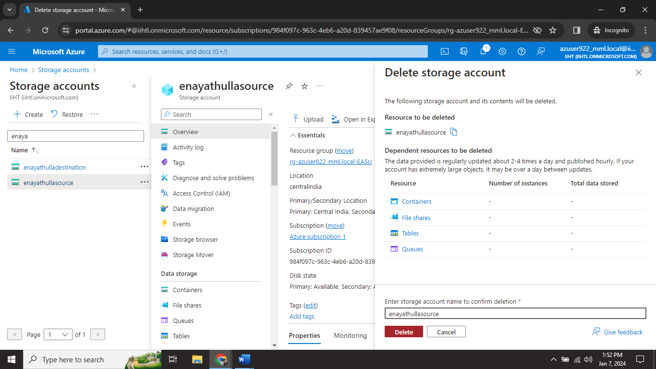

Step20🡺 delete destination storage account (enayathulladestination).

